**Jenkins Task-2**

**Task Description:**

Create a simple script file and push it to repo. Create a project in Jenkins connected to your GitHub repository. When a commit is made to your repo, automatically build must get triggered from Jenkins and the output must be shared to me via email.

Step1:

AWS EC2 instance created and launched Jenkins.

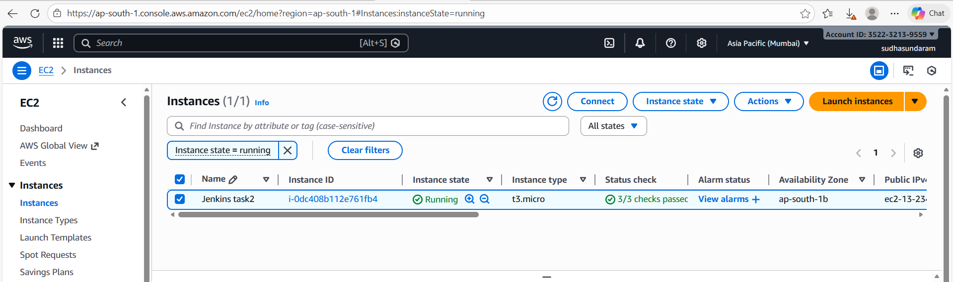

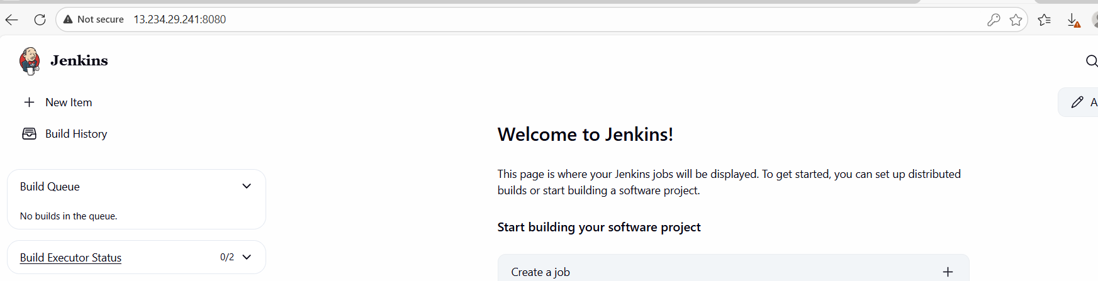

Step 2:

Created a new repository in github and generated PAT access token.

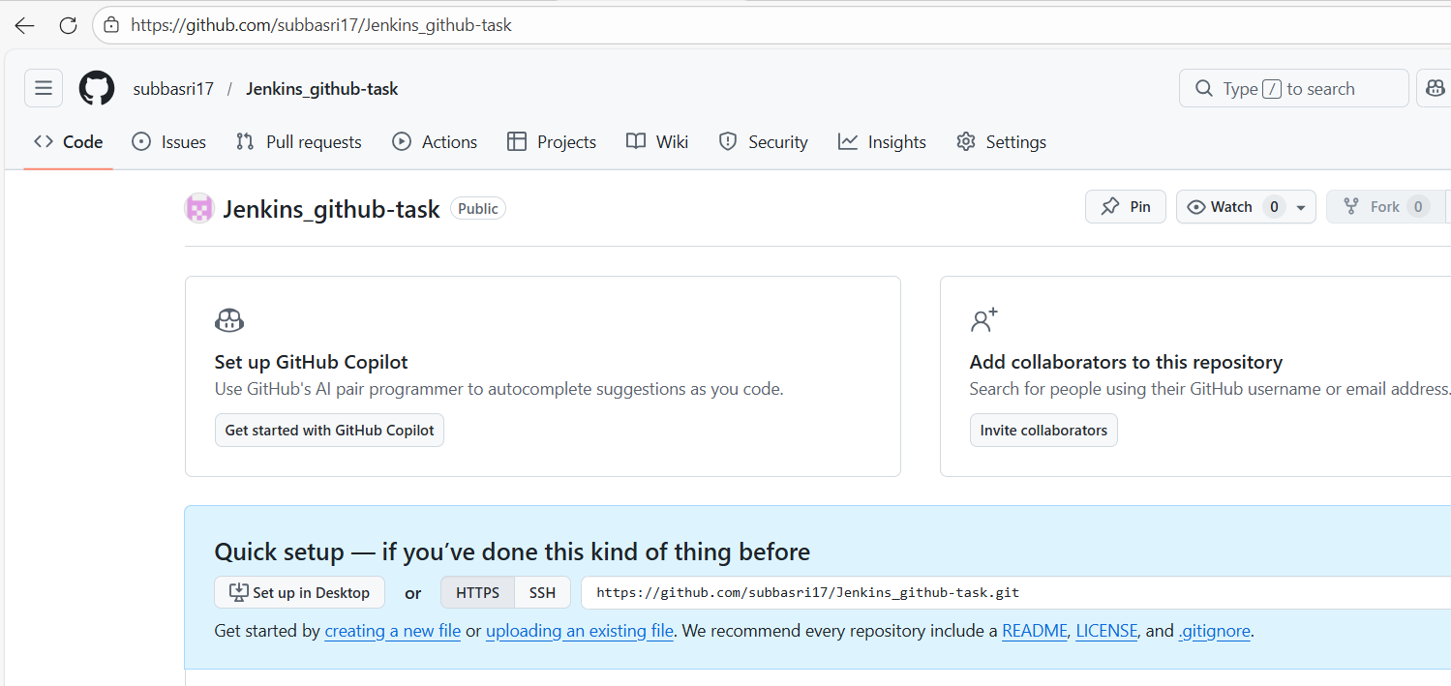

Step 3: File pushed from local repository to github.  
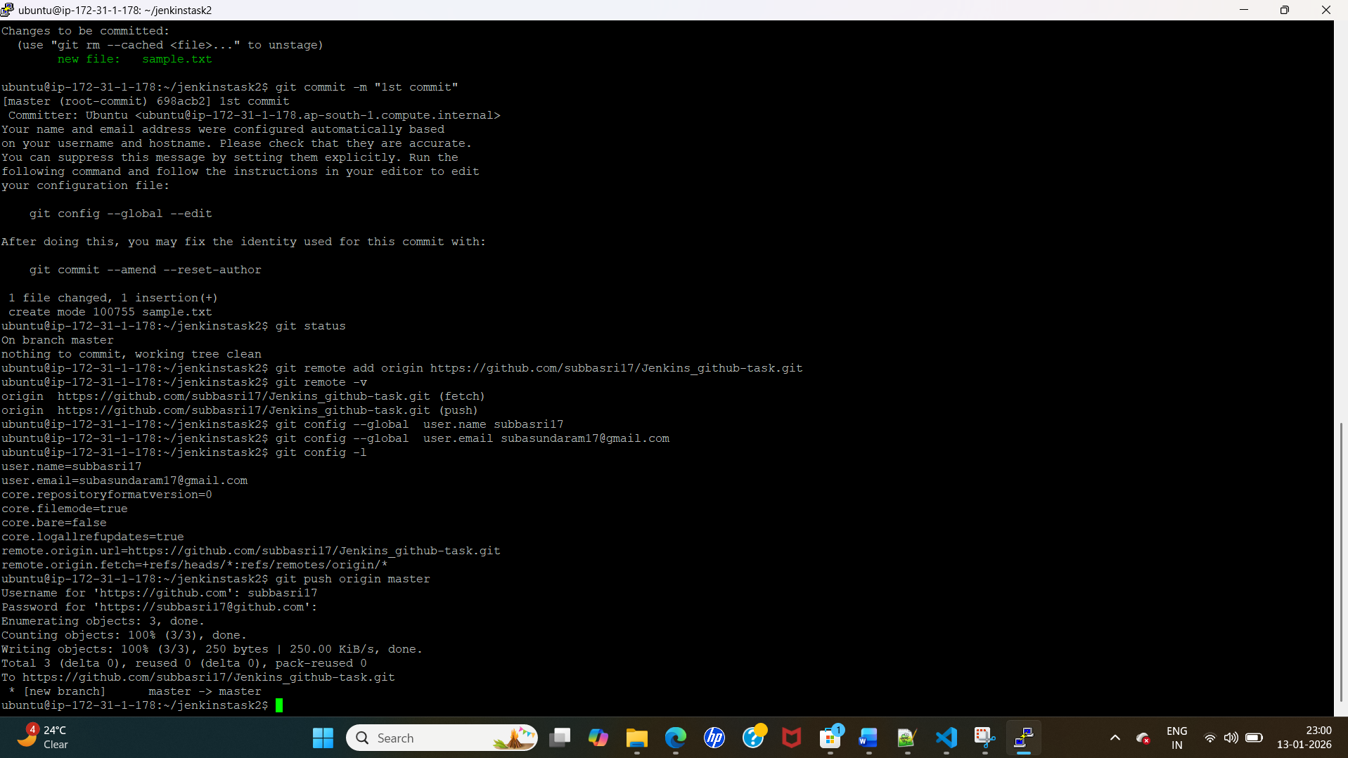

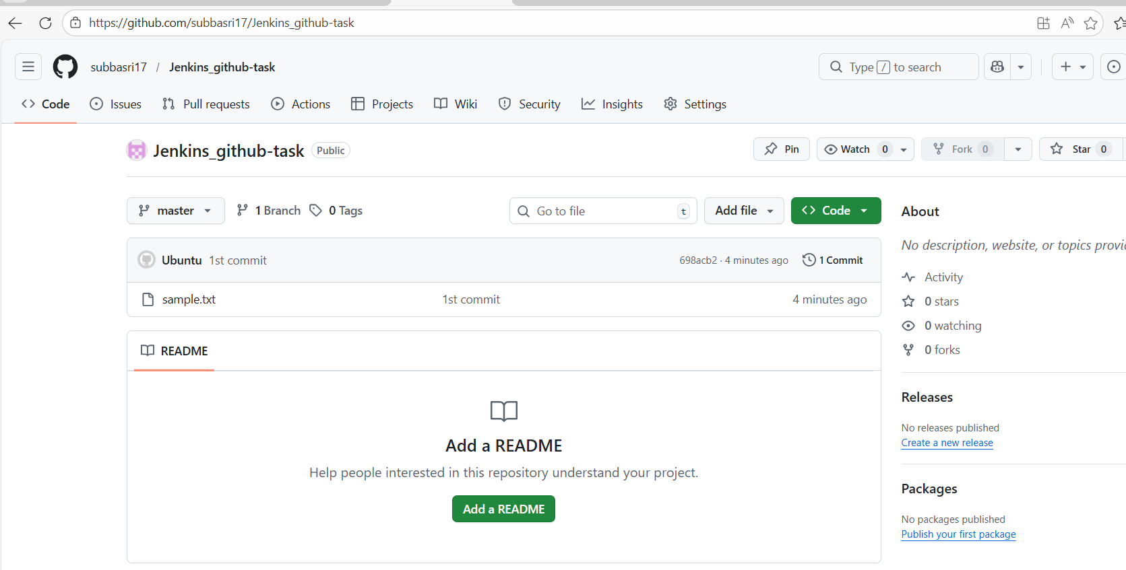

Jenkins: Provided Git hub URL in source code management in Jenkins and mentioned git scm polling under trigger by creating a new webhook project.

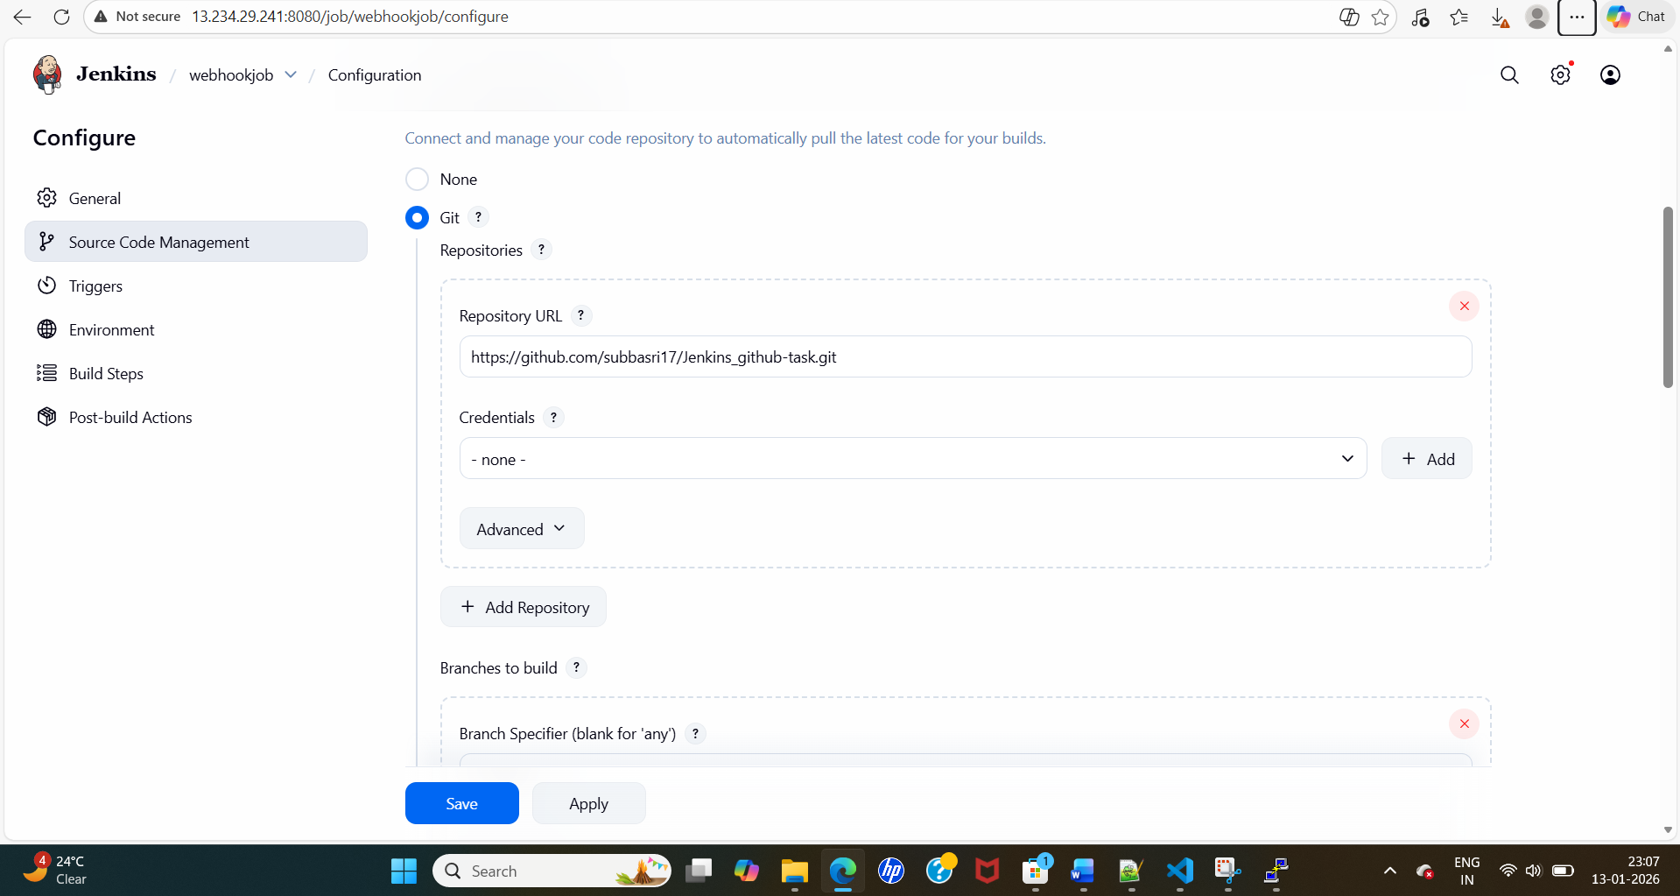

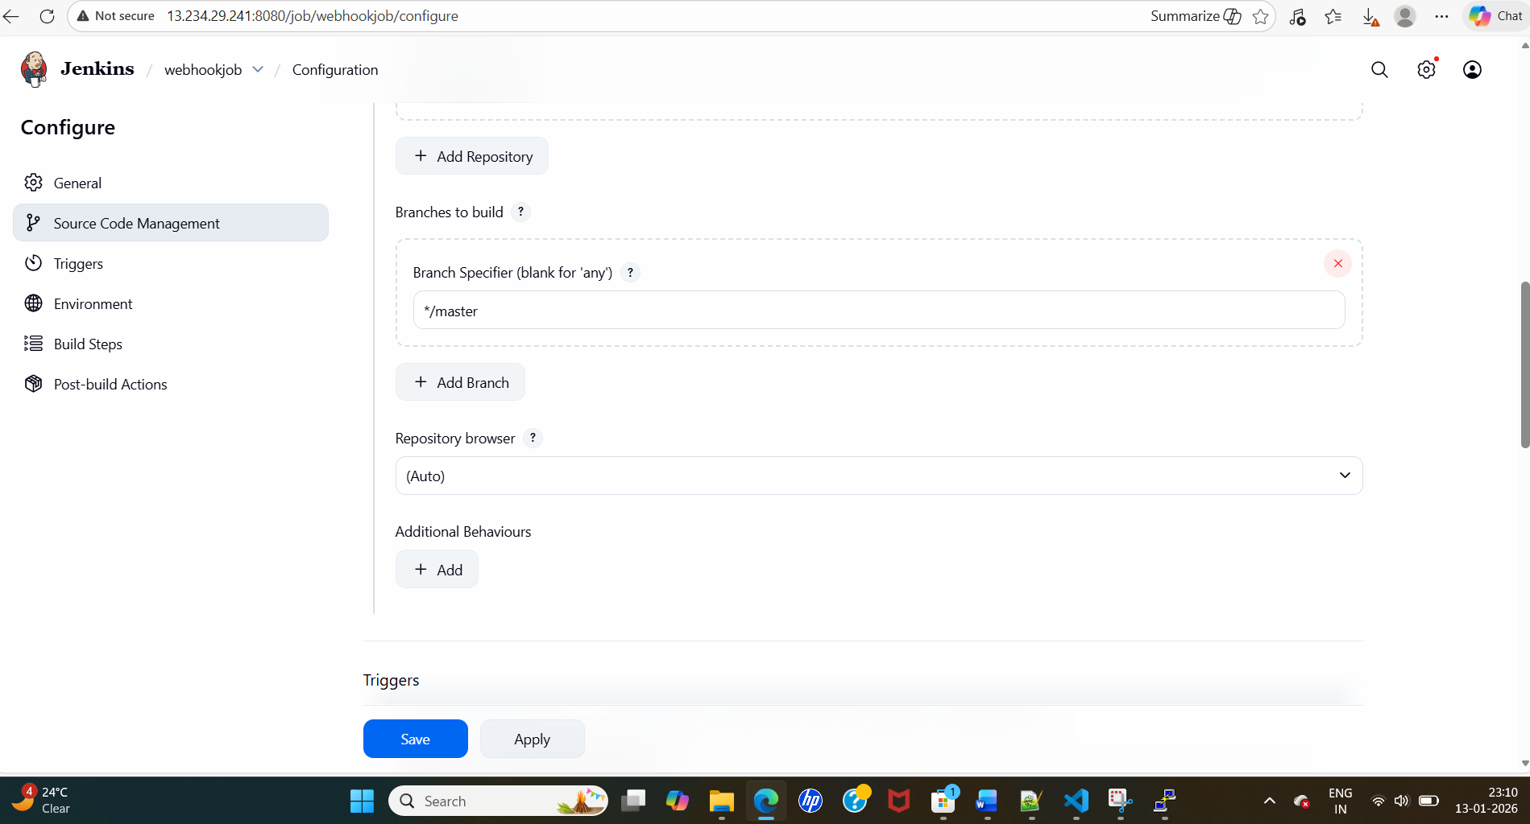

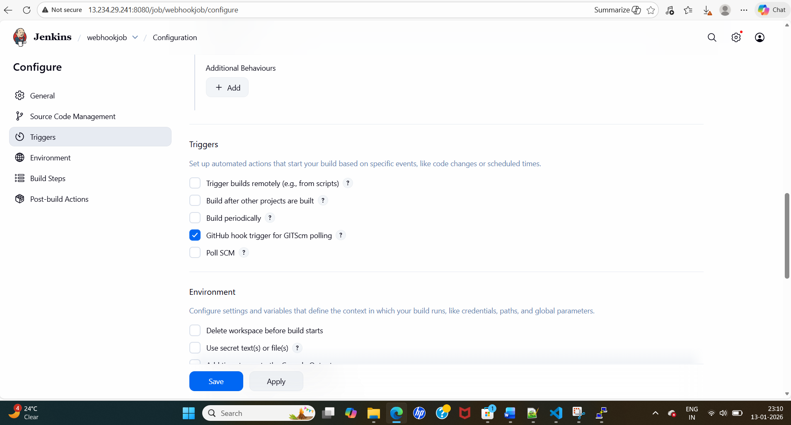

Step 5:  
Git hub: I need to provide Jenkins details to github two way handshake.

Go to repo settings – webhooks-add a webhook -provide a Jenkins payload url.

http://13.234.29.241:8080/

<http://65.0.170.152:8080/github-webhook/> - the name should be same

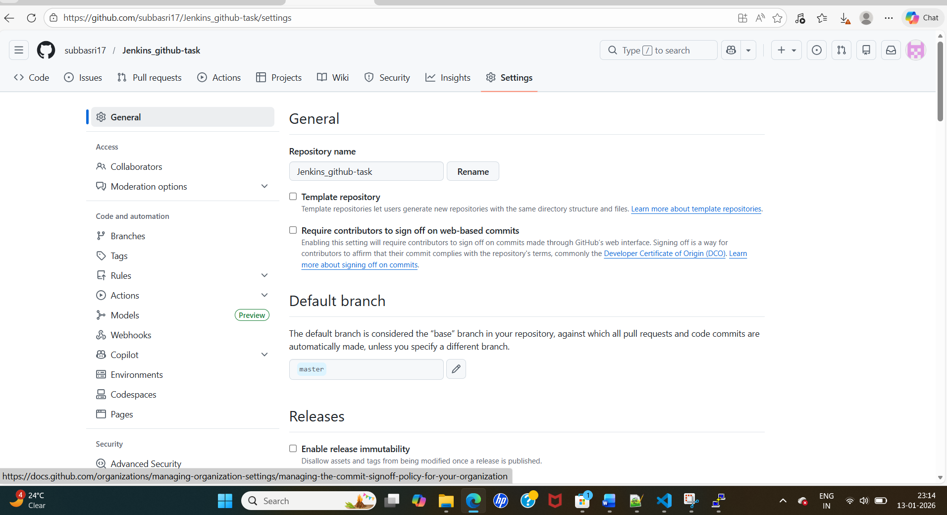

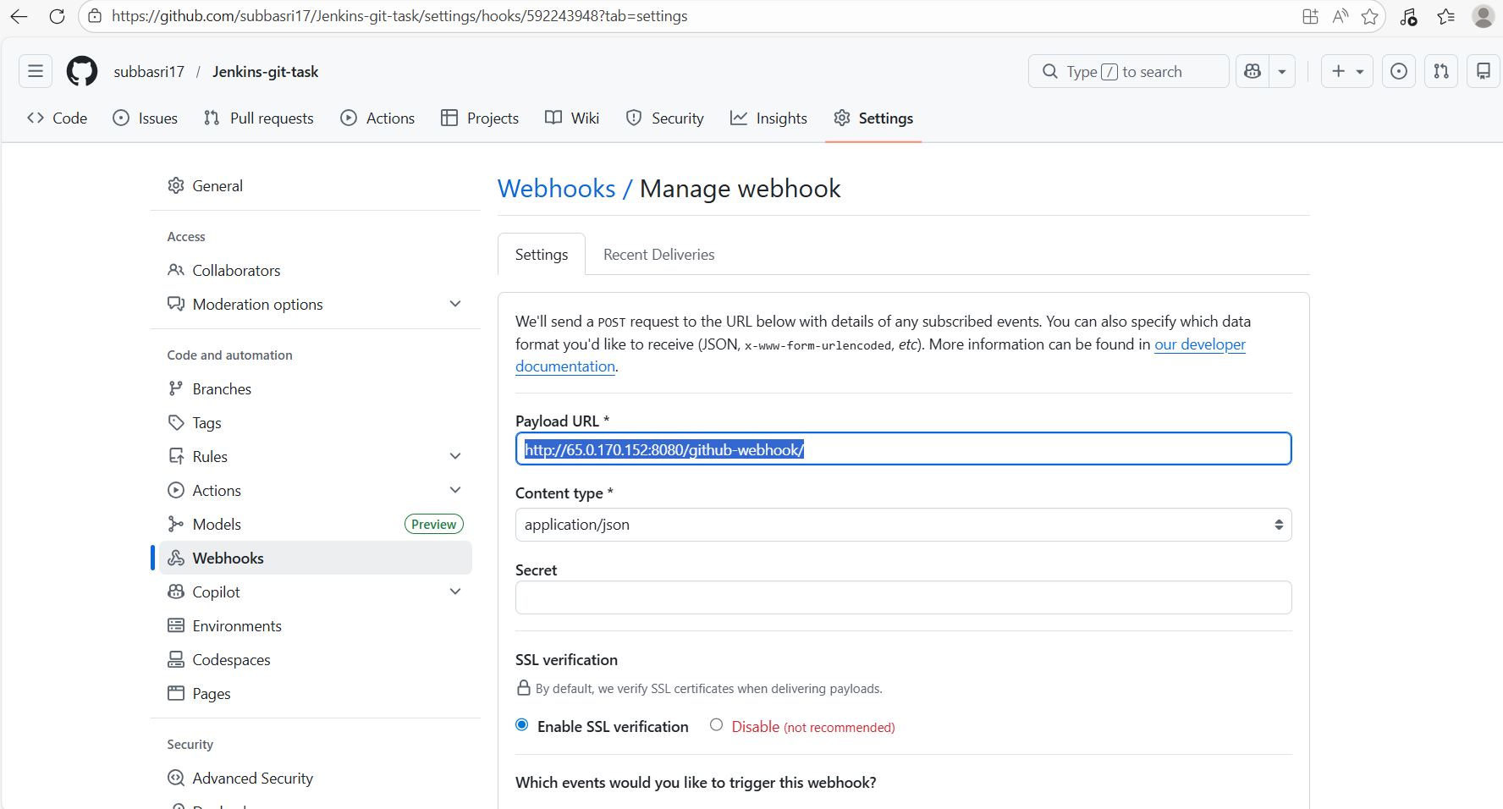

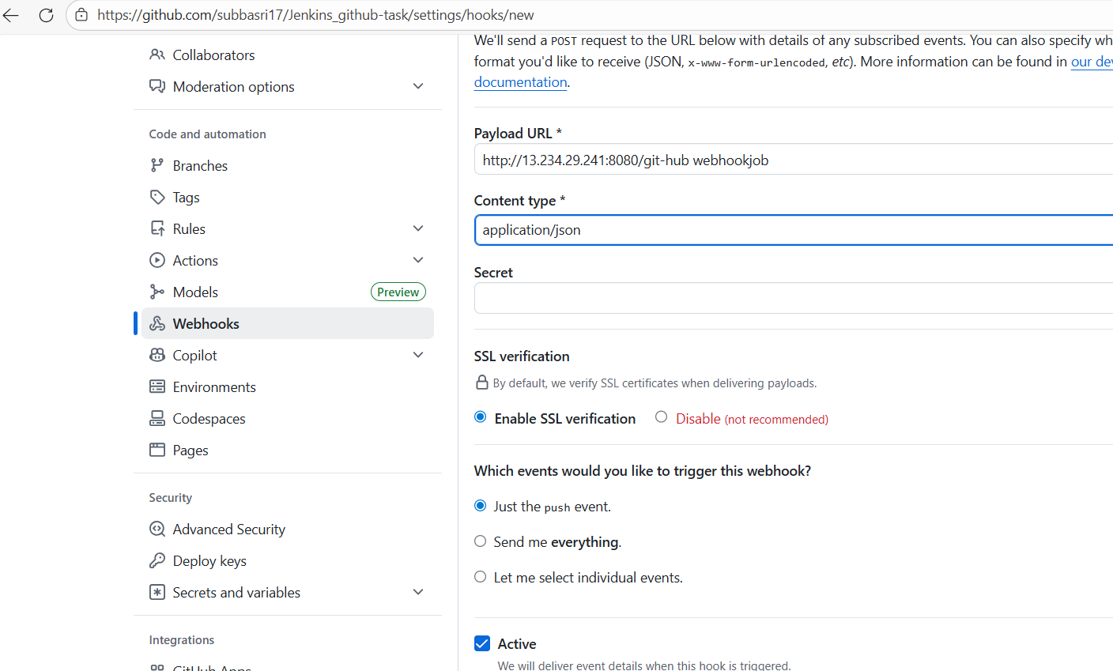

SSL certification disabled now, but real time we have SSL certification.

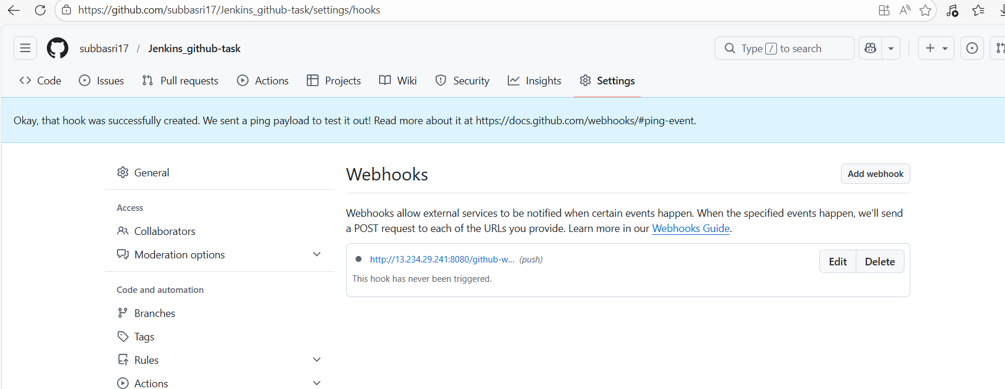

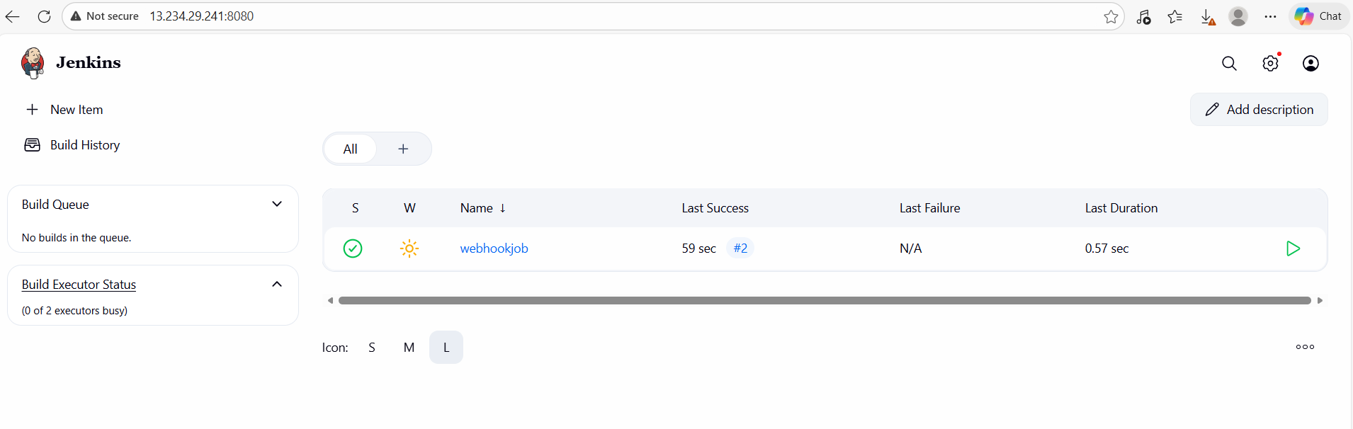

Doing some update and pushing the code In git hub, it will automatically get it from git hub and running.

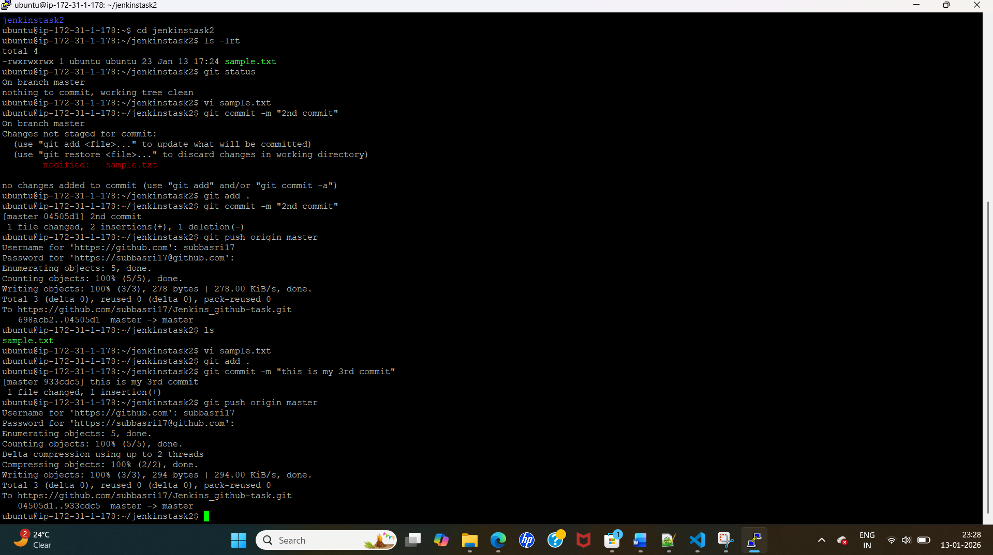

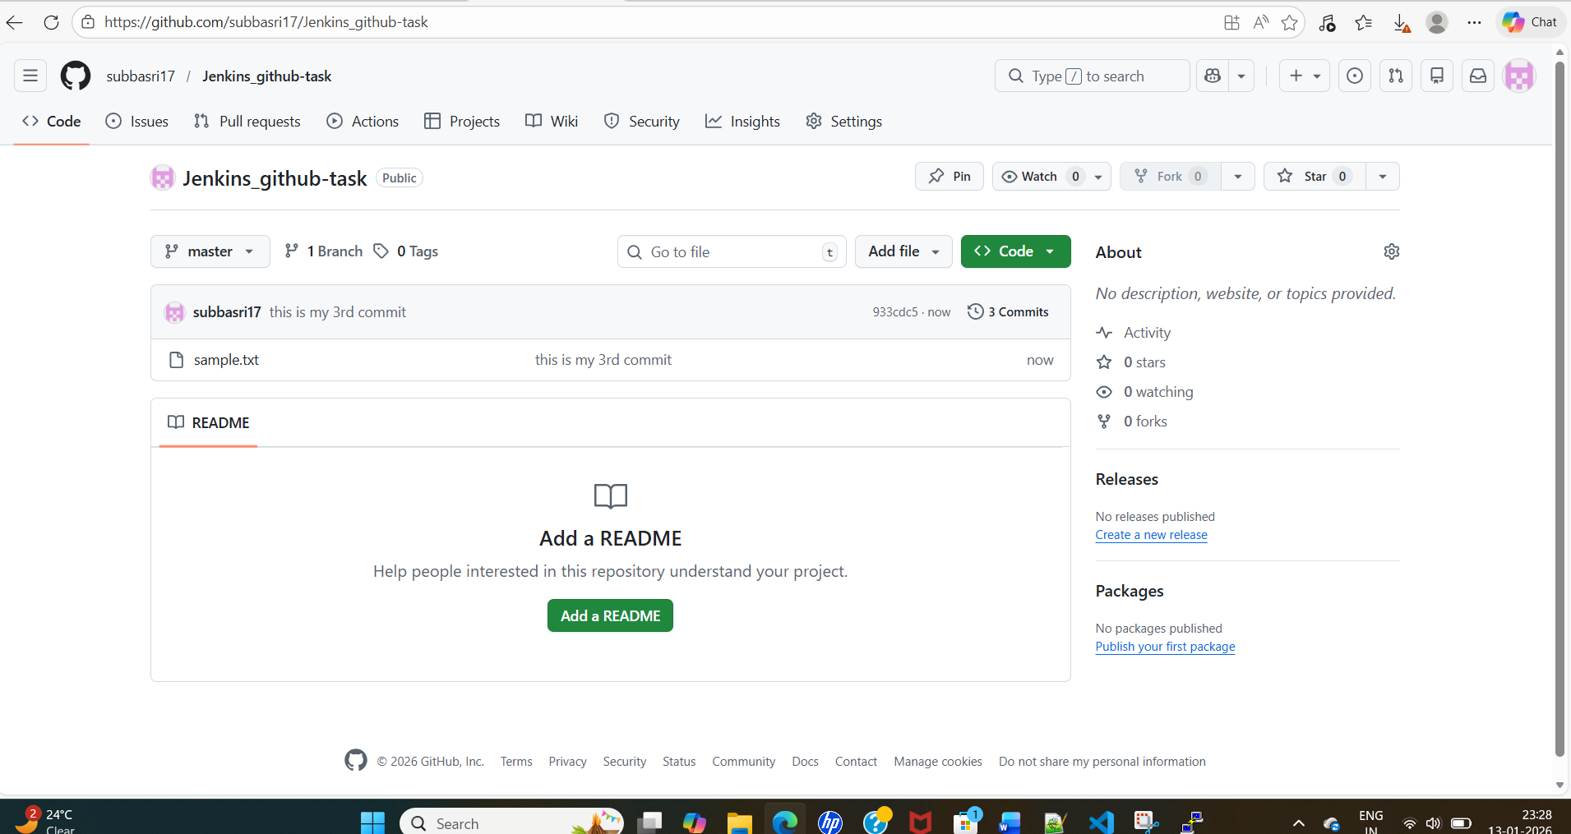

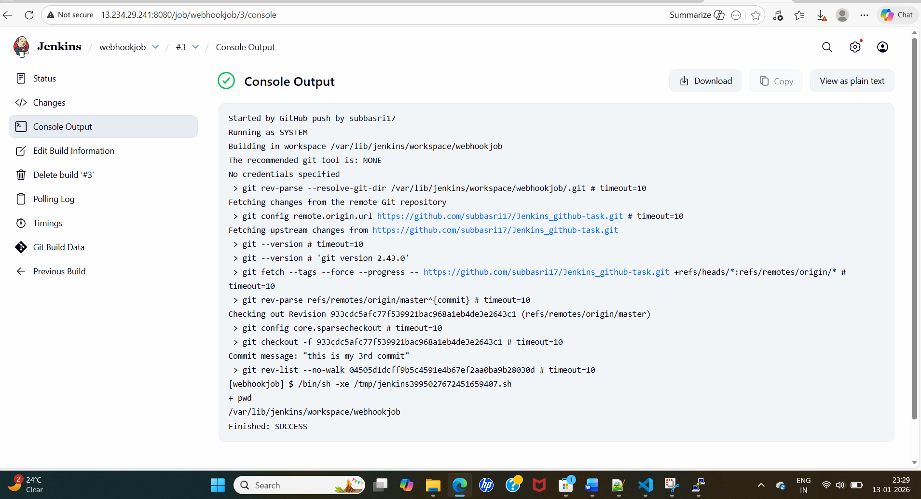

Email notification:

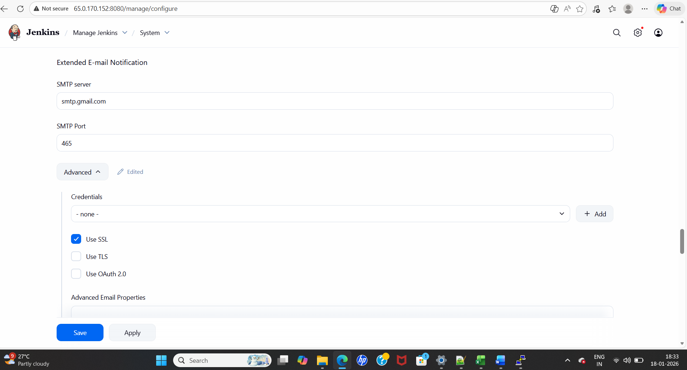

Credentials ->click add 🡪jenkins 🡪provide gmail id and password which created for APP password->then add

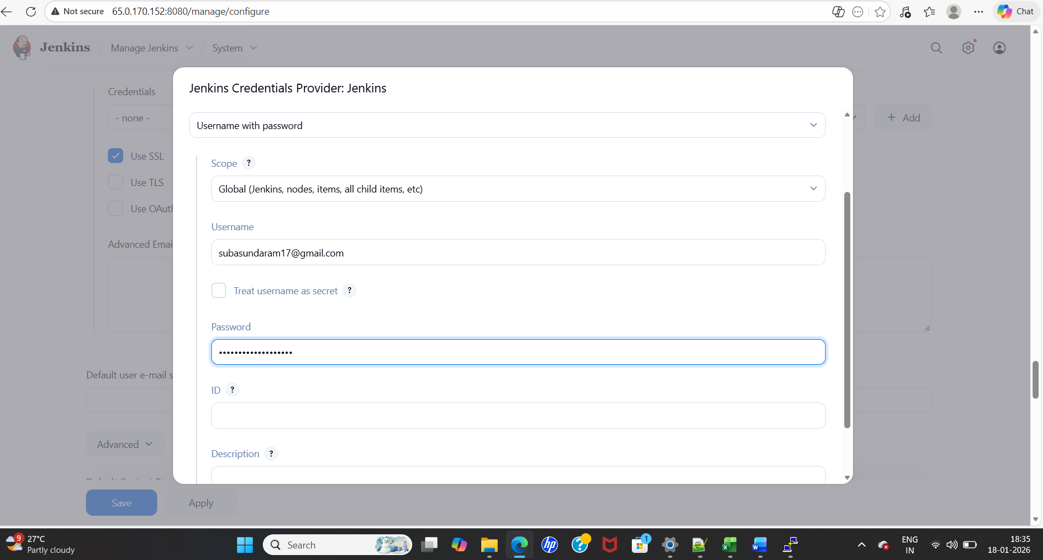

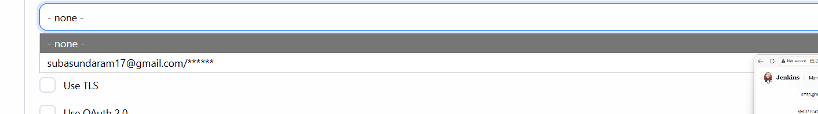

Give default email type and recepitant type

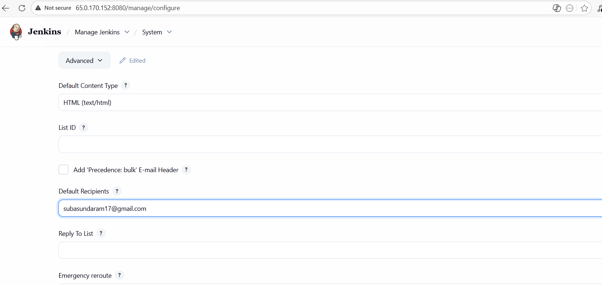

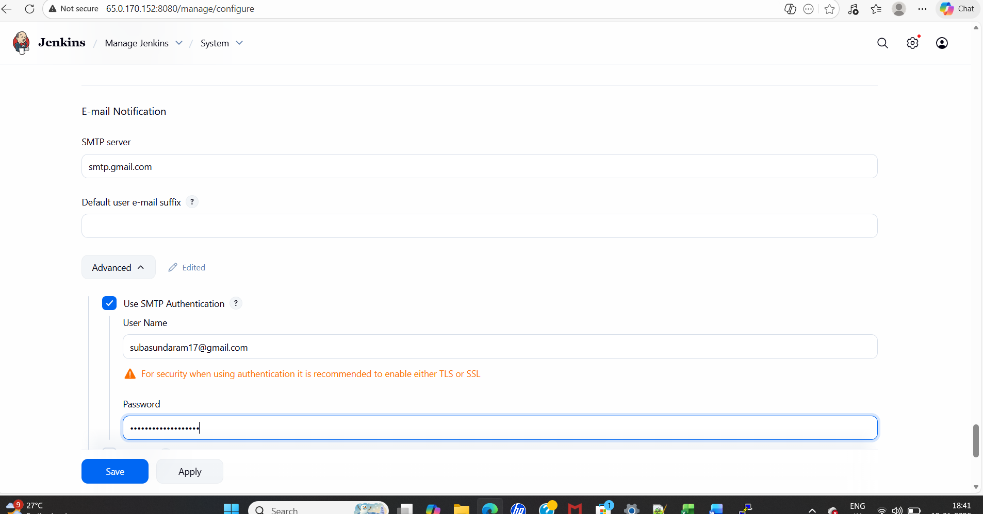

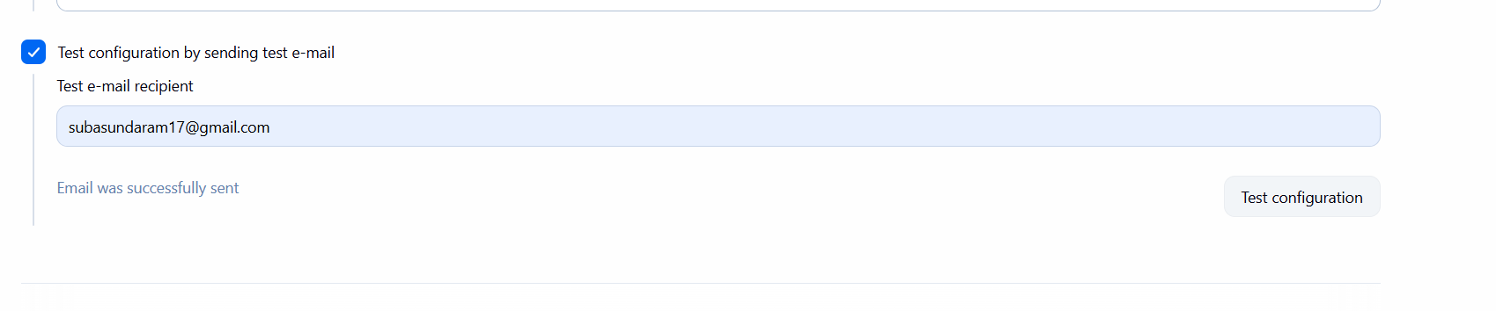

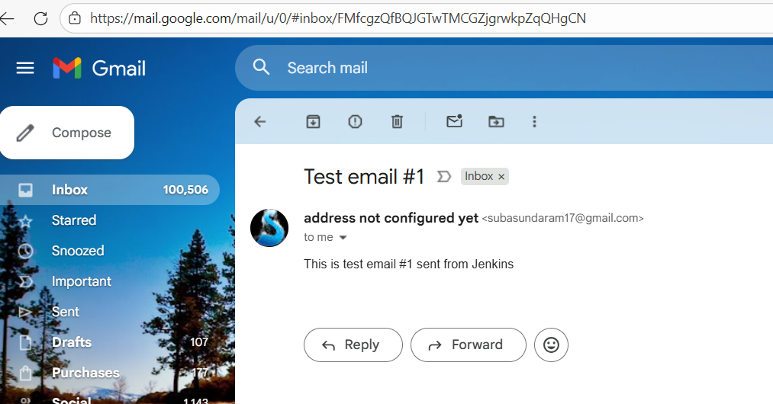

Email notification configured on Jenkins post build script

